**Assignment – 1**

1.) Install Power BI Desktop and share the final screenshot of the report view page which appears when power desktop starts.

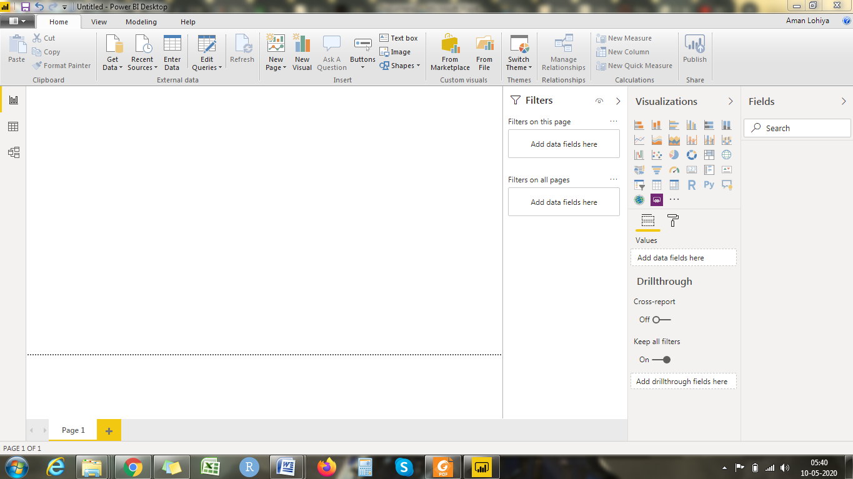

2.) Prepare a document and with the following screenshot –

Report View –



Data View –

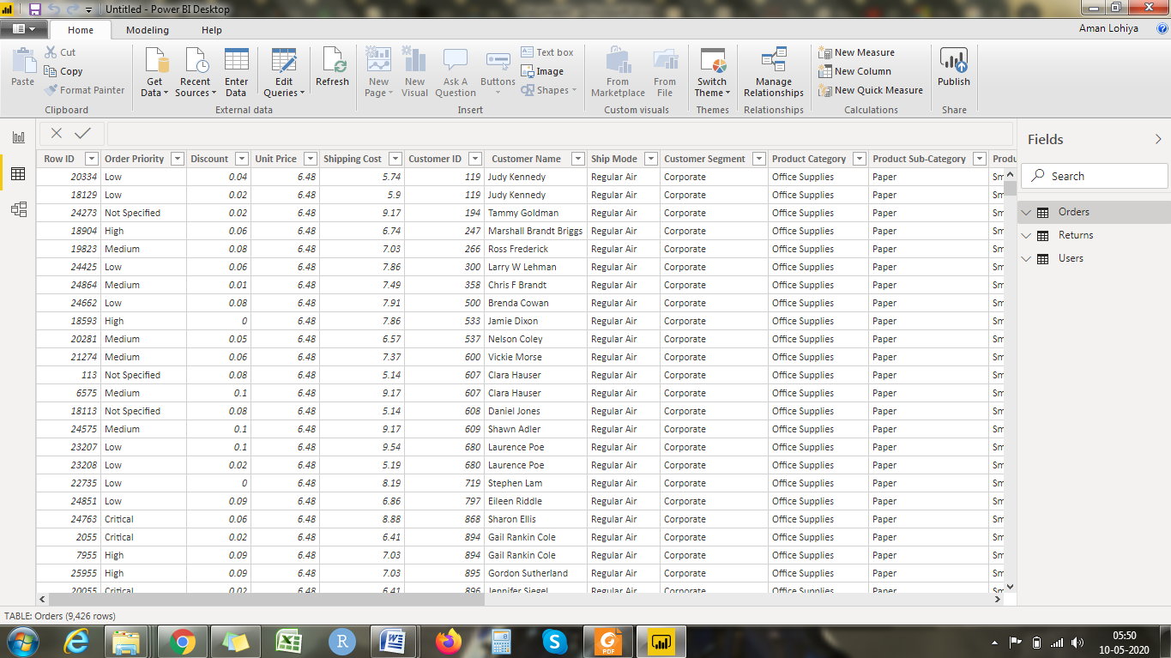

Model View –

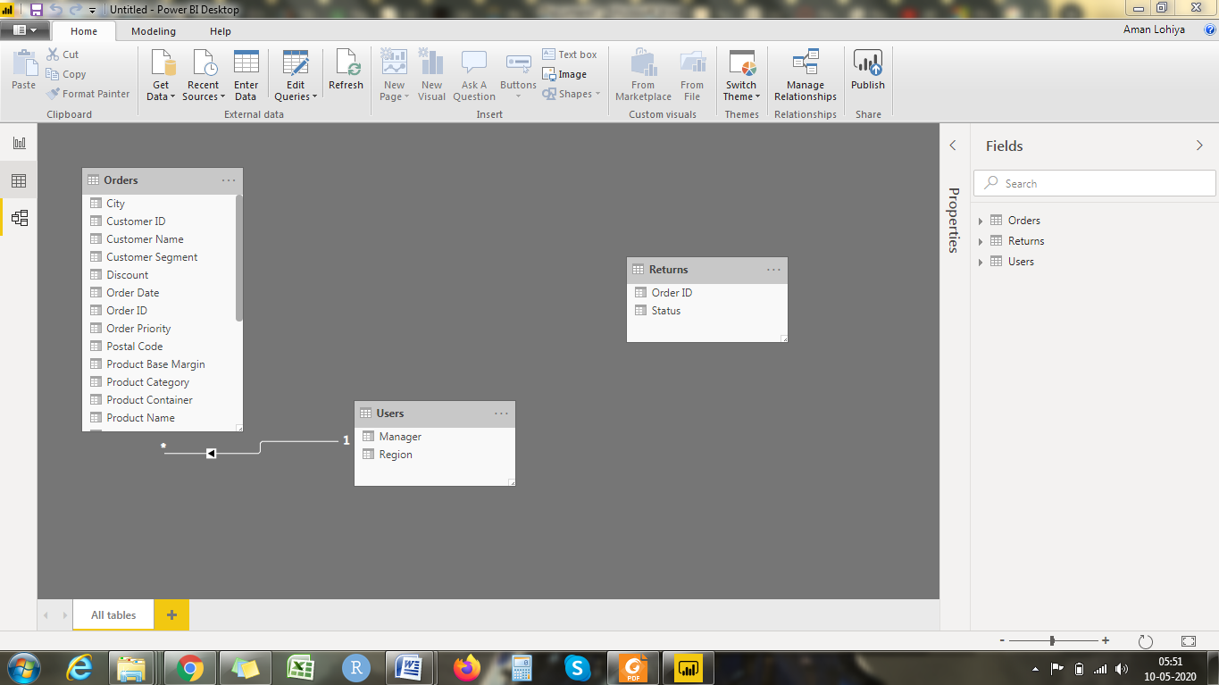

Power Query Editor −

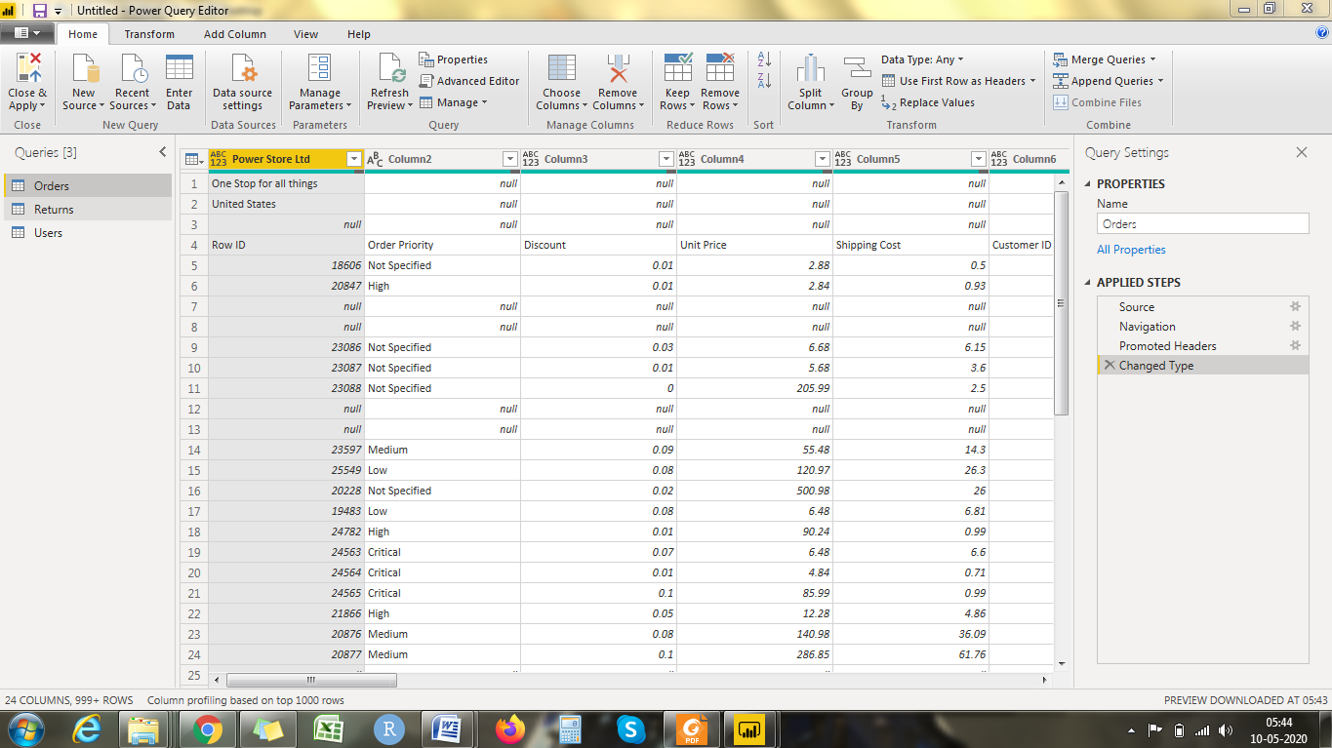

Advance Editor –

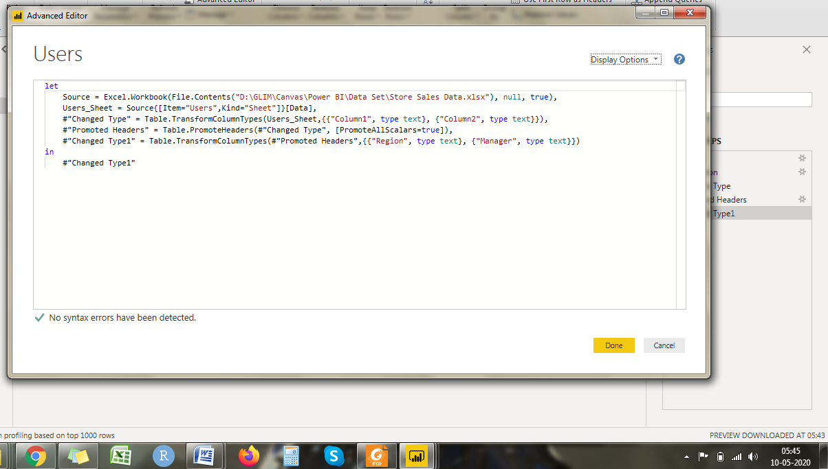

3.) Prepare a document with details of the following along with their price − Power BI Desktop – Free for Single user

Power BI Pro – $9.99/month

Power BI Premium- $4995/month